2024-25
Annual School Development Report

Avoca Collegiate



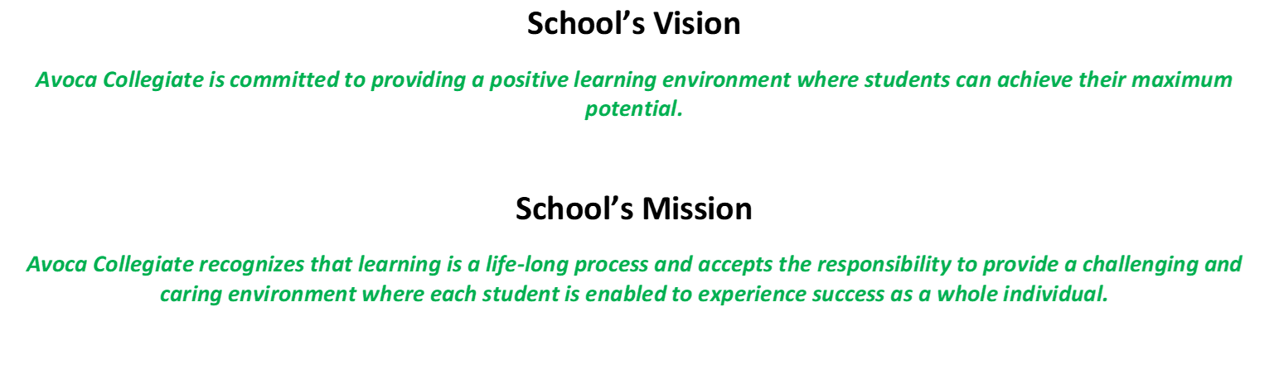

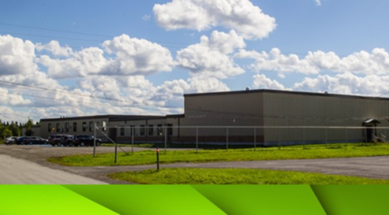

Goal: To realize school skills are valuable to real life.
Question: How do we shift class structures and pedagogy to optimize the learning environment?

Strategic Issue: Which determinant - Instructional Practices: To help students become independent, strategic learners; engage students; provide opportunities for feedback and student reflection; provide opportunities for classroom discussion.

How did you know this was a Strategic Issue? What evidence did you have?
Evidence used to identify strategic issue:

In 2024-25:
66.7% of students report a positive school climate
100% of staff report a positive school climate, up from 72.5% last year
83.93% of families believe Avoca has a positive school climate
58.6% of students report feeling as though they belong in school
32.3% of students are engaged in school
66.7% of teachers report positive self-efficacy, down 21.8%

Intermediate (7-9)
83.3% of students feel the behavior of others affects their own learning.
33.4% of students feel the physical space at school is either slightly unpleasant or neither pleasant nor unpleasant
57.2% of students feel other people at school understand them just a little or somewhat
28.6% of students feel they matter only a little or not at all to others at this school
57.2% of students report being either not eager to participate in any of their classes, or just a few classes
42.9% of students report they do not talk about ideas in their classes when not in school
61.6% of students do not see themselves as someone who values school
84.6% of students say they do not use ideas from school in daily life
Only 7.7% of students say they are interested in school (69.2% are indifferent)
46.2% of students are confident they cannot complete all assigned work in their classes
53.8% of students feel they will not remember what they learned this year, next year

Elementary:
40% of students say they do not use ideas from school in their daily life
50% of students report not being interested in school

RTL Forms:
40% of students K-6 have are being supported through RTLs
40% of students have a RTL in Literacy
20% of students have a RTL in Numeracy
3% of students have a RTL in SEL
Alternate Programs:
24% of students grade 7-9 are receiving support through alternate programs (Literacy, SEL, etc)
Year-end Summary of Progress. What evidence do you have to support this progress?

Our analysis indicates that we are successfully meeting most of these instructional goals. Teachers are consistently implementing strategies that support student independence through structured learning tasks and scaffolded instruction. Feedback is timely and constructive, and opportunities for reflection are embedded in both formative and summative assessments. Classroom discussions are a regular feature in lessons, promoting critical thinking and active participation.
However, one area identified for improvement is student engagement. While general engagement levels are satisfactory, we recognize the need to deepen student involvement and ownership of their learning experiences.
Next Steps…
Student Choice: Allowing students to make choices in their learning process—such as selecting topics, resources, or formats for assignments—can significantly boost motivation and relevance.

Student-Led Projects: Providing opportunities for students to lead inquiry-based or collaborative projects encourages autonomy, responsibility, and creativity.

Interactive Lessons: Increasing the use of hands-on, technology-integrated, and inquiry-driven activities will help make learning more dynamic and connected to real-world contexts

Goal: For students to feel more valued and have more choice in the school community.
Question: How do we create opportunities for students to see their worth?

Strategic Issue: Which determinant - Wellness & Positive Relationships: Wellness is a state of dynamic physical, mental, social, and spiritual well-being that enables a person to achieve full potential and an enjoyable life.

How did you know this was a Strategic Issue? What evidence did you have?
Evidence used to identify strategic issue:

PMF Data:
In 2024-2025:

Overall (K-9)
55.9% of students report a positive school climate
72.5% of staff report a positive school climate, the lowest in the past 4 years (down 5.5% from last year)
83.9% of families believe Avoca has a positive school climate
71.5 % of students report a safe, caring and inclusive environment (and 80% of families), the highest in the past 4 years (up 12%)
49.1% of students feel they are valued members of their school community
37.6% of students are engaged in school

Intermediate (7-9)
83.3% of students feel the behavior of others affects their own learning.
33.4% of students feel the physical space at school is either slightly unpleasant or neither pleasant nor unpleasant
57.2% of students feel other people at school understand them just a little or somewhat
28.6% of students feel they matter only a little or not at all to others at this school
57.2% of students report being either not eager to participate in any of their classes, or just a few classes
42.9% of students report they do not talk about ideas in their classes when not in school

RTL Forms:
3% of students have a RTL in SEL
Review 360 Data:
School wide data is limited. Behavior/safety concerns limited to a specific student.

Students have voiced they would like to:
Have more choice
Wear hats
Year-end Summary of Progress. What evidence do you have to support this progress? (What progress has been made on addressing the identified strategic issue? Have the actions taken moved the school forward in addressing the issue? What evidence have you used to determine this?)

Provide students with opportunities to offer ideas/suggestions
Leadership Committee
Passion Projects
Coding Fair
Badger Projects/Heritage Fair (community involved)
School Based Events
Volunteer Coaches (junior high)
Grandparents Tea

Regularly scheduled K-9 station activities
K-4 Lunchtime Basketball
Grade 3-5 Girls Basketball Tournament
Craft Club (?)
Sport teams for junior high (softball, basketball, volleyball)
House System Activities

Teach & Model the 6 C’s whenever possible (school wide implementation).
it has been shown through the activities that we are doing
it is built in and implemented through our teaching

Celebrate student and staff success (weekly gotcha draws, announcements, Google Classroom, Avoca Facebook, bulletin board display celebrating birthdays, awards, success, etc. )
Bulletin board was successful (students look forward to seeing it)
Weekly Gotcha Draw
Facebook Page successful (lots of activity)
Teachers continued to use Google Classroom
Student of the Month (meet together once per month)

Celebrating Diversity
Jay’s Care Program celebrated & welcomed diversity
Pride Day (Day in June)
Shine the Light Bulletin Board celebrate diversity
Expanded School Library on books about diversity
House/Spirit days

Next Steps…

To add on and continue with ongoing opportunities for students
Continue to pursue strong Leadership Community
Once a term, send out a Google Form Survey to students, parents and staff
Continue with fairs for more community-based events

Continue with House Activities
Utilize students staying in for lunch (For example: 2 sessions will run for 20 minutes each - First group eating while second group participates in activity of the day and then rotate during the second half)

Continue what we have been doing while making a conscious effort 6 C’s are included. Spotlight (activity) on 1 C each month

Giving out more Gotchas on a daily basis for Primary/Elementary (Revisit in the fall for an alternative - What qualifies for someone to get a Gotcha? )
Look at an alternative for Junior High (Ex: Giving an “award” for expectations met in class - Such as Dunkaroo Day/Class choice activities)
Continue with celebration of student & staff success
Posi-Note: positive communication to students (recognize a student doing good by writing a note and hiding it for them to find ex. locker, textbook, notebook, etc)

Continuation of what we have been doing and look for new opportunities to expand

