2021-2022
Annual School Development Report

Donald C. Jamieson Academy

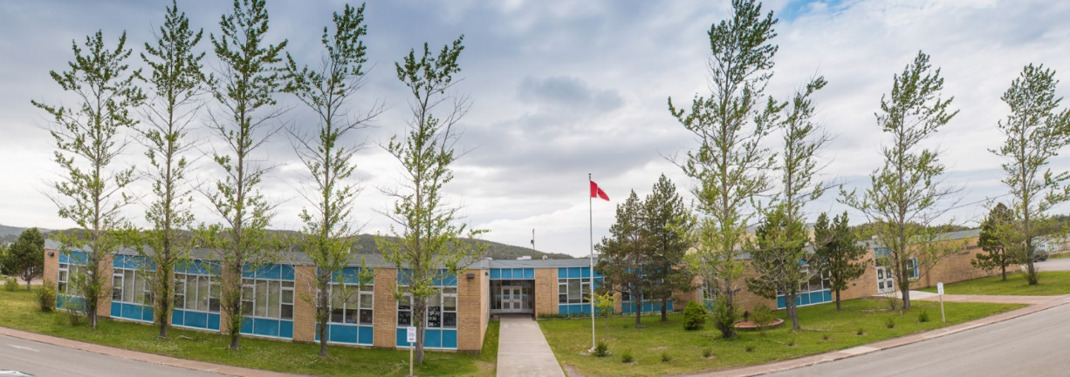

Strategic Issue/Goal: To incorporate wellness as an essential aspect of student achievement.

Objective: To build a more cohesive school community where students and families feel safe, connected/involved, and valued.

How did you know this was a Strategic Issue/Objective? What evidence did you have?
- PMF and SDS data for 2019-2020 and 2020-2021 school year was examined. We focused specifically on school belonging, school engagement, positive school climate and major behaviors.
- 2019-2020 and 2022-2021 Review 360 Data was examined.
- Through collaborative discussions at staff meetings, TLT Meetings and SDT meetings, we found that students and families are feeling disengaged due to a lack of school spirit and inclusivity.
Year-end Summary of Progress. What evidence do you have to support this progress?
The DCJA School Community made wonderful progress with this strategic issue during the 2021-2022 school year. With the exception of the creation of a Calming Room/Sensory Room, as well as specific Mental Health PL for staff, all other actions were achieved.
Next Steps…
As Covid protocols begin to lift, we plan to continue with the progress we have made. Specifically, we plan to increase the involvement of parents/guardians & community members by offering school wide events such as the Scavenger Hunts, Christmas Carnivals & Spring Flings.
Furthermore, we have applied for funding to assist in creating a Calming/Sensory Room, and we are planning to offer Mental Health PL during upcoming PL Days.

Strategic Issue/ Goal: To create an environment where all students are engaged in learning.

Objective: To develop an optional learning environment that maximizes instructional time and supports learning.

How did you know this was a Strategic Issue/Objective? What evidence did you have?
- PFM and SDS date for the 2019-2020 and 2020-2021 school year was examined. We focused specifically on student engagement, positive school climate and major behaviors.
- 2019-2020 and 2020-2021 Review 360 Data was examined.
- Through collaborative discussions at staff meetings, TLT Meetings and SDT meetings, we found that there is a wide range of academic abilities in a K-7 school and a number of students at each grade level struggling with the curriculum.
Year-end Summary of Progress. What evidence do you have to support this progress?
This strategic issue has only partially been achieved.
Although new technologies such as Chromebooks, iPads, docking stations & an interactive television have been purchased the Technology Lab was not upgraded, and is currently not usable. Due to last minute renovations of our Science Lab, the Technology Lab is now being used to store science equipment and is not accessible to students. This room therefore cannot be used as an extension of the classroom, however the LLC often is.
Furthermore, although the greenhouse was upgraded and is ready for use, work is still needed on the outdoor classroom and the gardens around the school.
Next Steps:
We plan to continue to invest in technology, as we feel there still are not enough devices to best suit the needs of all of our students. Furthermore, we hope to get the Science Lab/Technology Lab renovations completed soon so that we can once again use both spaces.
Finally, the school council has plans to help upgrade the grounds around the school in the Spring of 2023.

