2023-2024
Annual School Development Report

St. Michael’s Elementary
Stephenville Crossing

St. Michael’s is committed to helping students grow together socially, emotionally, intellectually, physically, and spiritually, with respect for self and others thus, becoming responsible, caring citizens of an ever-changing world.

Strategic Issue:
Increase reading comprehension school wide though the implementation of Science of Reading concepts
How did you know this was a Strategic Issue? What evidence did you have?

We know this is a strategic issue for the school from the data provided by the k-6 reading records over the past number of years. Although the school has had some success improving student success in reaching grade level at Grade 3, there are still too many students not approaching grade level at this point.

Currently reading at grade level in Sept 2023 by grade

Grade 1: 1/7
Grade 2: 1/16
Grade 3: 3/16
Grade 4: 6/16
Grade 5: 10/18
Grade 6: 8/16
Grade 7: 10/16

The drop off in success rates in Grade 1-3 can be attributed to a number of reasons, notably time missed due to the pandemic and markedly different class composition. However, these issues underline the need of the school to respond to the needs of the students in the primary grades.

Year-end Summary of Progress. What evidence do you have to support this progress?

Next Steps…

Strategic Issue:
Increase student engagement at all levels
How did you know this was a Strategic Issue? What evidence did you have?

The annual PMF data showed weaknesses in these areas

2.1 Positive school climate (Student): 50.1% positive
2.4 School Safety (Student): 57.5% positive
2.6 School Belonging (Student): 48.8 positive
3.1 School Engagement (Student): 42.8% positive

Specifically, the data involved:
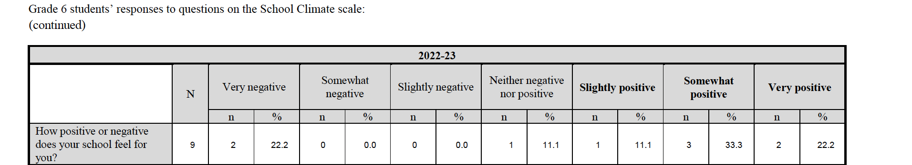
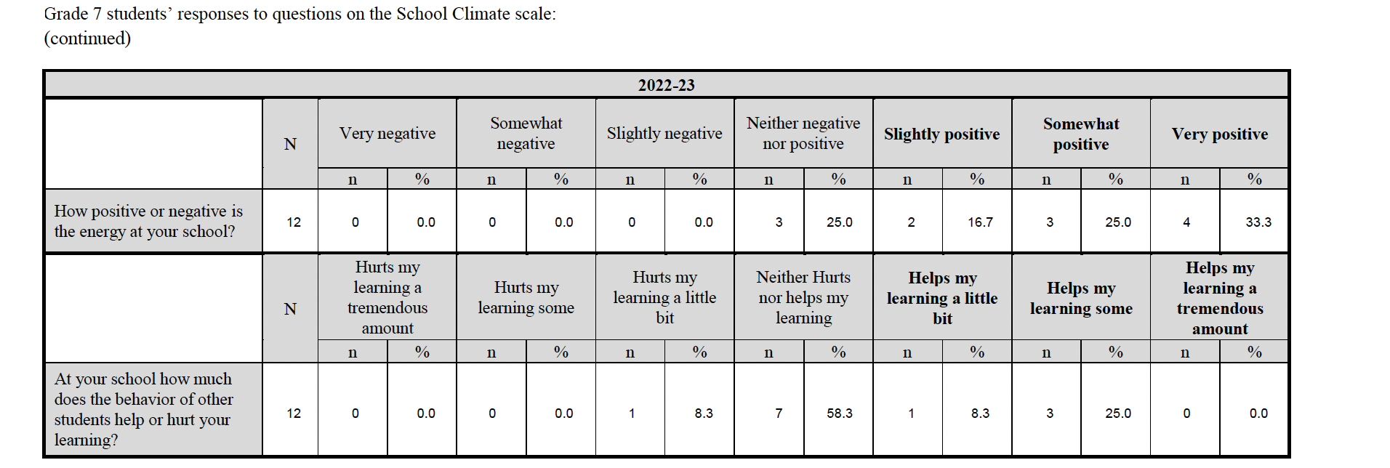
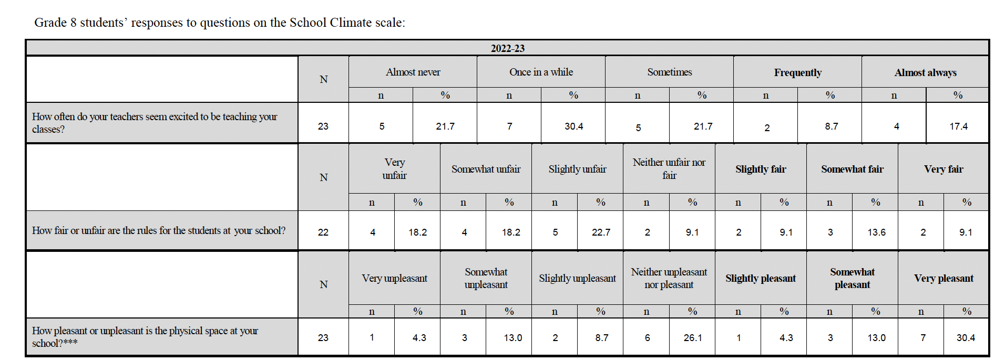
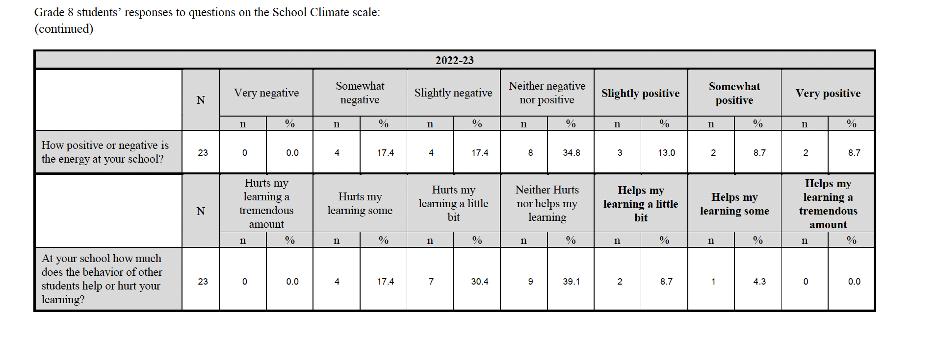
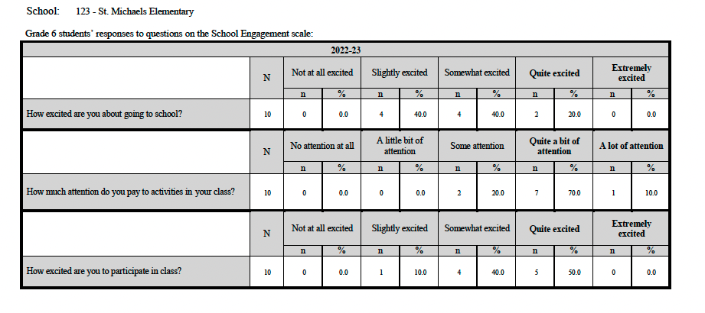
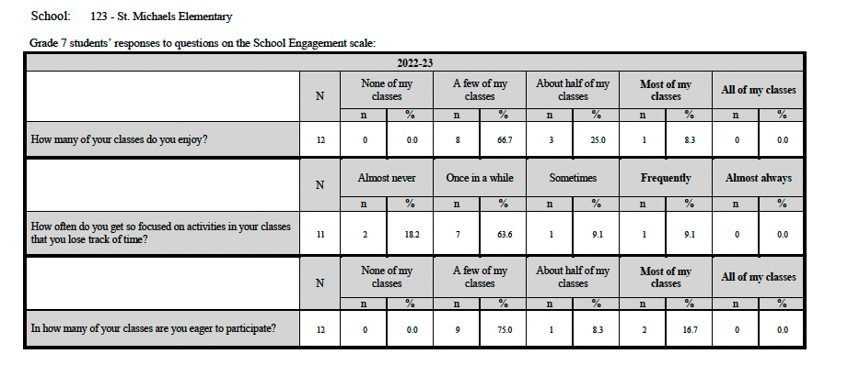
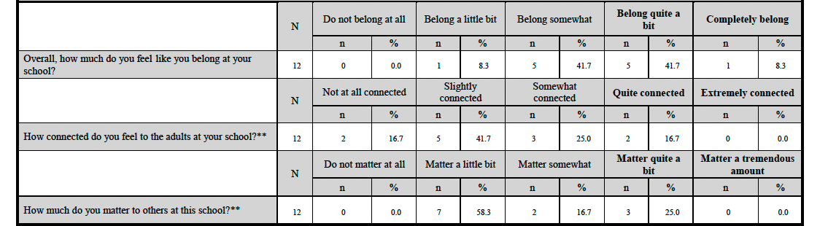
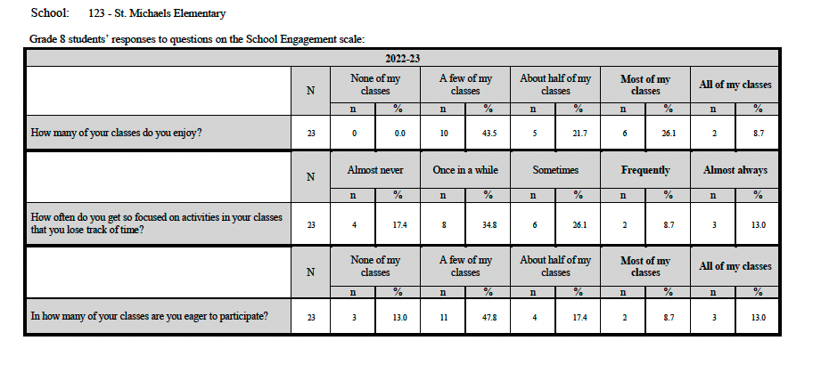
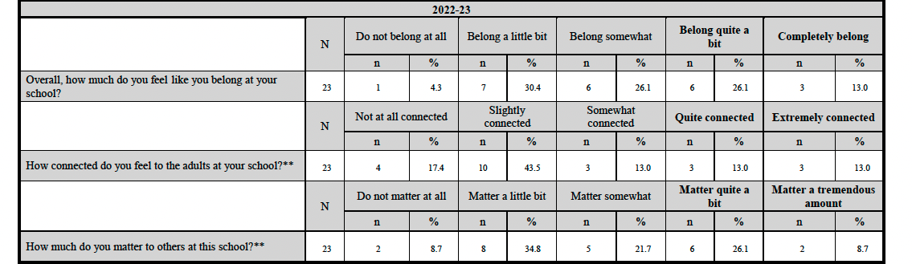
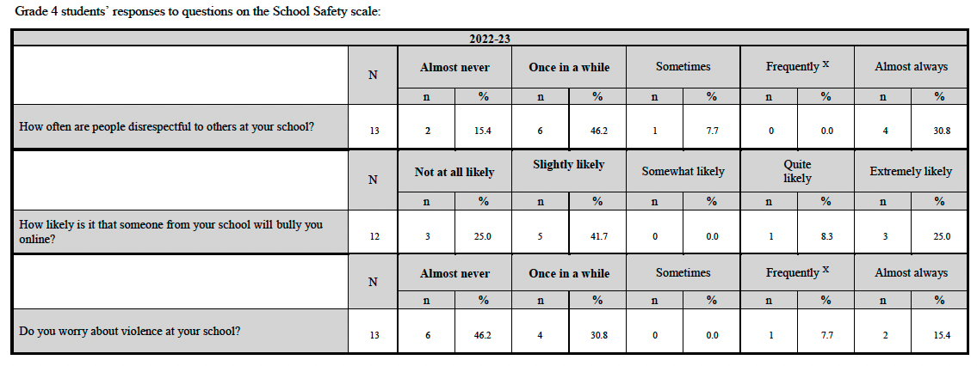
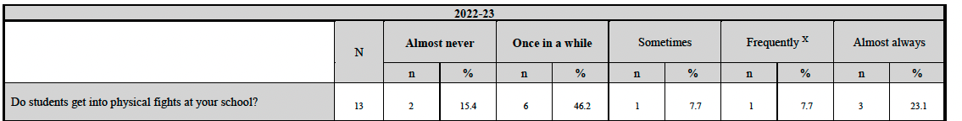

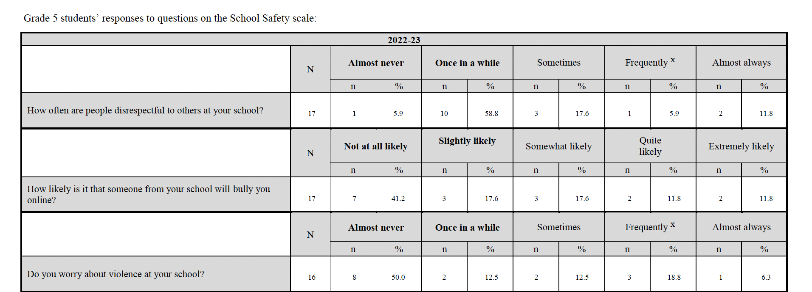
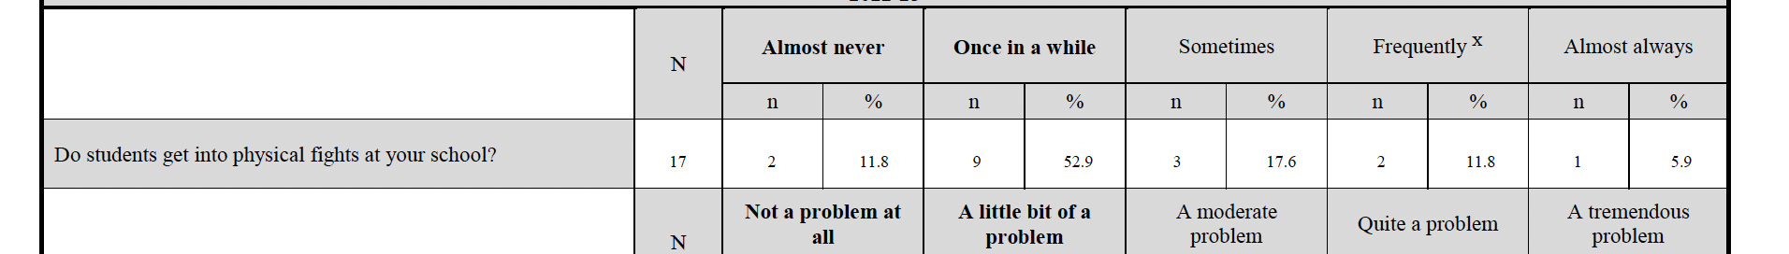
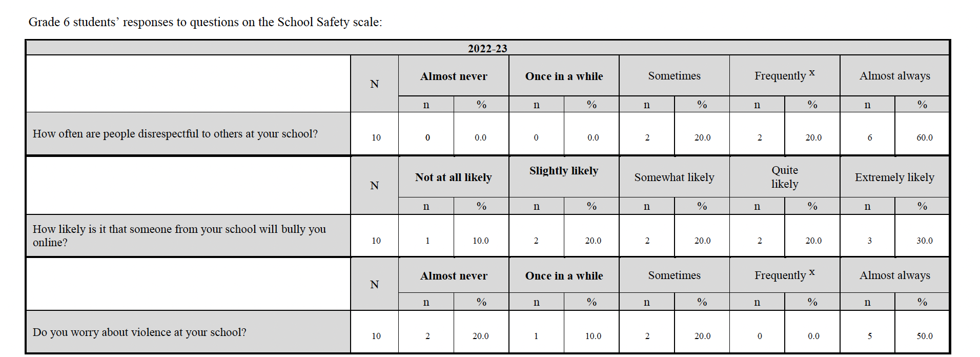
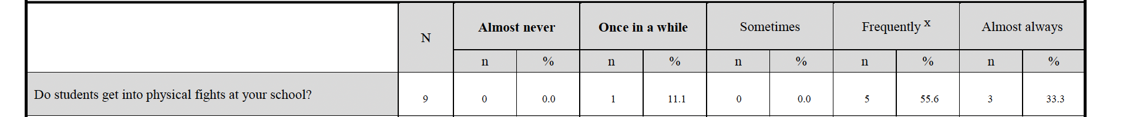
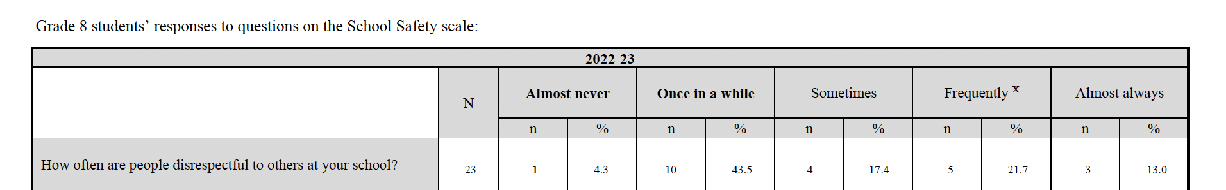
Year-end Summary of Progress. What evidence do you have to support this progress?

Next Steps…

