OUR LADY OF THE CAPE
Annual School Development Report 2022-2023

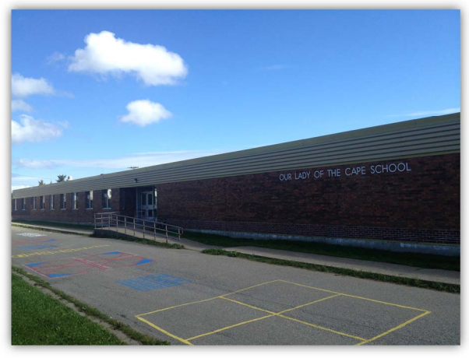
875 Oceanview Drive | Cape St. George, NL | A0N 1T1
Home, School, and Community Working Together!

Strategic Issue: To continue to build positive learning and supportive relationships within the school and community. (Determinant: Wellness and Positive Relationships)

How did you know this was a Strategic Issue? What evidence did you have?

The data/evidence used to determine this strategic issue included: staff conversations, student council conversations, school council conversations, report card data, SD survey data, PMF data, and evidence based observations.

Year-end Summary of Progress. What evidence do you have to support this progress?

As a staff, we developed four actions to address our strategic issue. The actions included: to provide more opportunities to increase family involvement, to promote positive mental health awareness and initiatives for students and staff, to promote positive physical health practices in school and at home, and to provide opportunities to collaborate with outside agencies.

As a staff, we felt that our actions had a direct impact in progressing towards the accomplishment of our strategic issue. We provided numerous opportunities to increase family involvement at school. This included invitations going out to all parents/guardians/community members for the following: curriculum night, literacy days, various fundraisers, KES volunteers, Terry fox walk, concerts, sporting events, school council membership, and various ways to complete School Development Surveys. We promoted positive mental health awareness and initiatives for students and staff through various presentations (via guidance and public health), participation in global initiatives (i.e. stand up day, Bell let’s talk day), and numerous inclusionary practices. We promoted positive physical health practices in school and at home. This was done by numerous informational sharing of resources with families (i.e. healthy eating, hygiene, and sleep), student participation in SSNL events and intramurals, and our continued KES program (grab n’ go). Lastly, we had various opportunities to collaborate with outside agencies (i.e. Abade Farms, Mi’kmaq center, French center, People of the Dawn, Francofit, CYN, Cadets, etc.).

Evidence to support this progress came from staff and student conversations, conversations with parent/guardians, conversations with various councils and outside agencies, improved SD survey data, improved PMF data, evidence based observations, improved Review 360 data, increased frequency of relevant student/staff activities, increased family/outside agencies involvement in school wide events, improved report card data, and increased presentations from guidance and public health.

Next Steps…

As a staff, we had numerous meetings (Fall 2023) to discuss our current School Development Plan (2022-2023), to decide if we will be keeping the same strategic issue for our new plan (2023-2024).

After much discussion and data analysis, we decided as a staff that it’s time to change our strategic issue and develop a brand new plan for the 2023-2024 school year.

During our last close-out day, as a staff we developed a new plan. Our new strategic issue is: To continue to design physical and social environments that maximize instructional time and support learning for all. (Determinant: Optimal Learning Environments). We currently have three actions developed to obtain our goal/strategic issue. We will continue to edit,revise, and revisit our plan throughout the year.

