E.A. Butler All-Grade 200-394
Annual School Development Report
2022 - 2023
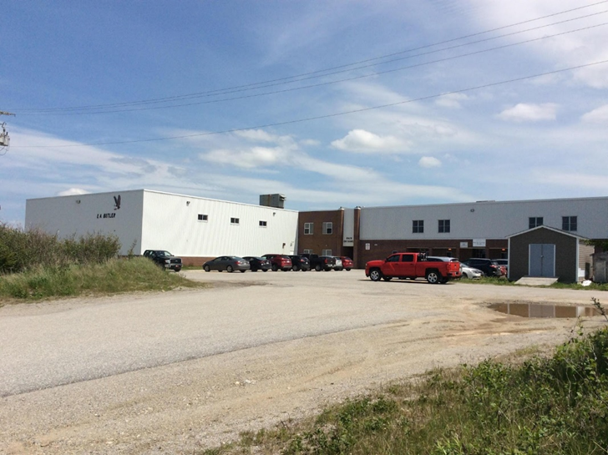
We are a K-12 school focused on creating a positive and supportive environment that encourages students to achieve their maximum potential! Our students and staff have worked hard to develop an inclusive school with a positive school culture, where everyone experiences success.

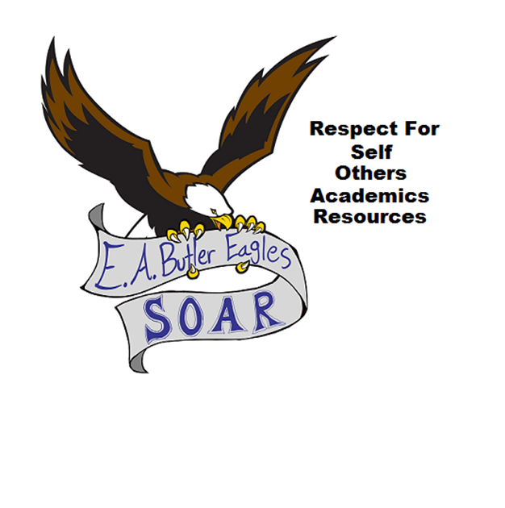
We believe in Respect for:
Self, Others, Academics and Resources

E.A Butler Mission Statement:

To create an environment where respect for self, others, academics and resources is the norm, ultimately promoting the social, moral, emotional, and academic development of lifelong learners, adaptable to a changing society.

EA Butler All-Grade (#200394)
Box 10
McKay’s, NL
A0N 1G0
(709) 645-2330
EAButlerAll-Grade@nlesd.ca

Strategic Issue: Optimal Learning Environment
Strategic Question: How can we, as a community, maximize an 0ptimal Learning Environment?
How did you know this was a Strategic Issue? What evidence did you have?

-According to classroom observations and feedback, improving student motivation and engagement still continue to be areas requiring more focus.
-Student absenteeism (particularly toward the end of the school year) was also an indicator of a lack of focus and motivation. Unfortunately, this must also address the data collected through the reasons for the absenteeism; parents primarily excused their children or never notified the school as to the reason for the absenteeism. (All K-12 parents were also notified through Smartfind if their child was absent from school and a reason was not provided.) This is more of an issue regarding grades 7 to 12 students.
- Records of students leaving school in afternoons, without permission
- Records of interventions for missing work and/or assessments indicated a lack of motivation for some students.

Year-end Summary of Progress. What evidence do you have to support this progress?

- Based on activities highlighted through PBS assemblies and feedback from students, some teachers are really trying a variety of different activities with their students to enhance motivation in their classes. However, there are teachers who are still not engaging in exploratory/hands-on activities with their students.

-Partnerships from external community organizations have been very well received by students and parents, (such as the Penpal Program/Visits with Crosswinds Seniors Resort and New World Dairy), but this occurs more with the primary/elementary classes as opposed to with high school students
-There is evidence some classrooms are not utilizing the abundance of technological innovations or even devices as a part of teaching and learning, particularly in grades Kindergarten to Grade 3. (ie. Data collected through Chromebook sign-out sheets and evidence of computers/laptops not being utilized.) Students enjoy using various means of technology in their lives, whether it be to explore and discover or to play games, even if they are educational. This should be embraced and used to motivate students.
- Most teachers are utilizing a variety of means of assessment to assess students’ learning (Evidence in 7-12 Gradebook)

-Most 7-12 Teachers continued to use Google Classroom to post missed classwork for student absent from school

Next Steps…
-Teachers could complete reflections of self-assessment questionnaires to determine if they are not using a variety of engaging/hands-on activities in their classrooms will include this as a focus in the Professional Learning Journeys.
- Teachers will be encouraged to use various technological tools in their teaching and learning.

- Most teachers will continue to utilize a variety of means of assessment to assess students’ learning

Strategic Issue: Wellness and Positive Relationships

Strategic Question: How can we improve staff and student overall wellness?
How did you know this was a Strategic Issue? What evidence did you have?

-Overall comments from staff and students
-Referrals to Guidance
-Review 360 Reports
-Meetings with staff, students and parents
-Meetings with District Personnel and Union Representatives (NLTA) regarding teacher wellness

Year-end Summary of Progress. What evidence do you have to support this progress?

-Staff PD Days have focussed on teacher and staff wellness, but it still needs to continue
-Presentations and events scheduled for students have been well received and appreciated, based on feedback from students and parents (ie. LiveDifferent, Indigenous Teachings in classes)
- The EA Butler School Facebook site still recognizes and highlights achievements. This is a positive action that elicits favorable comments from parents and should continue.
- During the Strategic Planning Day in October, Teachers were encouraged to send home a positive email to one student/parent once a week. This was started, but needs to continue.

Next Steps…
-Recognition of achievements and celebrations have proven to be positive and should continue
-Teachers and staff should lead by example and promote a positive school culture as much as possible
-Teachers and staff should continue to try to engage with all students
-Partnering with outside agencies continue to bring in a large variety of activities and views

