2021-22
Annual School Development Report

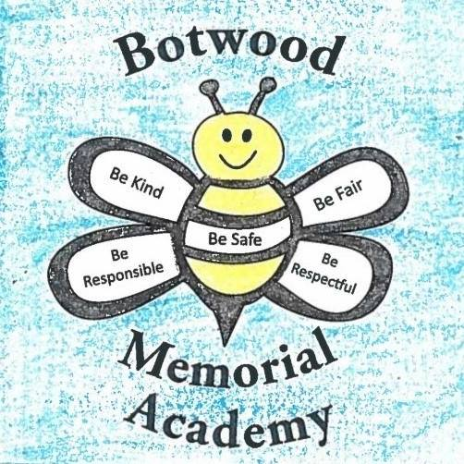

Strategic Issue:

Strategic Issue: Instructional Practices
To continue to foster a culture of learning; build upon collaborative structures, maintain a focus on leveraging digital, with an emphasis on student engagement and academic success.
How did you know this was a Strategic Issue? What evidence did you have?
Performance Framework Data, BEV data, RTL records, Attendance Data, School Council Data, Referrals to Guidance Counselor and Service Delivery Team.

Year-end Summary of Progress. What evidence do you have to support this progress?

Focus Area | Evidence to support progress
- Leveraging digital across the curriculum | An action team was created to target the effective use of technology in the classroom.  Several teachers received Pl in maker education from the Coding and Maker Education Itinerant, as well as PL in Minecraft Education & WeVideo.  Students across many grade levels are fluent in the use of the Google platform. Teachers are using technology and maker education on a regular basis. We currently have 97 Chromebooks & 30 iPads that are used on a constant basis.
- Increased focus on Responsive teaching and Learning | Professional learning was offered around implementation of Literacy Blocks and UDL. There has been some PL offered by the k - 6 math itinerant, as well as PL for the school-based RS & TL.
- Continue to implement hands-on and deep learning initiatives within the school. | An action team was formed to brainstorm instructional practices that would lead to improved student engagement. Throughout the school year we held monthly school development meetings in which teams met to plan deep learning initiatives. Some of the initiatives that occurred in our school this year included but were not limited to:  -Scientists in Schools. All students received virtual presentations from Scientists in Schools that were curriculum related.  -Brilliant Labs. Several teachers received grants for funding for coding & maker space technology. Our makerspace is used on a regular basis and teachers are incorporating coding and maker technology into the curriculum.  -Little Green Thumbs, SucSeed & hydroponics. Teachers in grades 3 & kindergarten partnered with Little Green Thumbs, as well as our Active Schools Coordinator, Corey Samson, to grow vegetables and herbs in their classrooms.  -Outdoor Garden. We have built several outdoor planters and all students were involved in planting seeds.  -Botwood Mural Arts Society & World Oceans Day. All students were involved in a presentation around World Oceans Day delivered by the Botwood Mural Arts Society & DFO.  -Raising Chicks - The grade one teachers partnered with our Active Schools Coordinator, Corey Samson, to raise chicks.  There were many activities in Wellness Wednesday that also promoted deep learning which included: messy science, Human Rights, maker space, guided art & bird feeders.
- Schedule and implement a meeting for Teaching and Learning Teams to identify student literacy/numeracy & SEL needs | Bi-weekly TLT meetings are scheduled and all staff participate. Grade level teachers, RS & TLAs share a common prep. Staff regularly review and update Responsive Teaching and Learning Records.

Next Steps…
-Continue to allow common planning time and bi-weekly teaching and learning team meetings to allow for teacher collaboration
-Continue to provide PL around deep learning
-Continue to provide PL to incorporate technology into instruction and assessment
-continue to provide technology/coding PL
-continue to implement monthly action team meetings around instructional practices and technology integration
-update technology infrastructure to include more WAPs, allowing better use of WIFI

Strategic Issue:
Wellness and positive relationships
To foster a safe and inclusive learning environment where health and mental well-being are incorporated into everyday practices.

How did you know this was a Strategic Issue? What evidence did you have?
Performance Framework Data, Attendance Data, Review 360s, School Council Data, Referrals to Guidance Counselor, Referrals to outside Agencies (Doorways, CSSD), Meetings with Students and Families

Year-end Summary of Progress. What evidence do you have to support this progress?

- Implement SEL strategies to all students | There has also been a focus on mental health & well-being for strategies for staff. Staff We provided two Pl sessions to promote staff well-being, as well as strategies staff can provide to students:  -Staff Wellness Strategies PL - offered by our Guidance Counselor  -Trauma Informed Practices and De-escalation Strategies PL - offered by our Educational Psychologist  Staff report more strategies to use when students require SEL interventions.
- Specific Days/activities to support student/staff wellness | Understanding that well-being is an essential aspect of student achievement, we have worked to improve wellness and positive relationships. Wellness Wednesday came about through review of the Wellness and Positive Relationship determinant during a school development session. Staff recognized that wellness and positive relationships influence school culture and improve student engagement. This year we were successful with the implementation of Wellness Wednesday. Wellness Wednesday focused on activities/sessions to improve wellness and positive relationships with a focus on comprehensive school health. Students participated in 12 sessions over a 6-week block. Sessions included: Outdoor Cooking, Technology, Human Rights, Yoga, LGBTQ2IA2S+, Messy Science, Healthy Eating, Digital Citizenship, Makerspace, Guided Art, Outdoor Scavenger Hunt & Bird Feeders. We received positive feedback from students, staff and school community. Student engagement was evident during the sessions. There were zero incident or behaviour problems reported during the Wellness Wednesday sessions, indicating improved student engagement.  In addition, we offered the Qualipu Outreach Program as a means to increase awareness & an opportunity to connect to Indigenous culture.
- Restorative Justice Practices | Two staff members participated in Restorative Justice Professional Learning. We had regular visits from our Safe and Inclusive Schools Itinerant. Students and staff were involved in many activities throughout the year, including Orange Shirt Day & Pride Month.
- Utilize Optimal Learning Environments | We have begun the process of updating many learning environments. Our Guidance office, maker space, quiet room (140), library and upstairs computer room have been utilized. Our Guidance office has been improved to allow students a relaxing environment to take a break.
- Family Engagement | Fostering connections between the school, families and the community has been a focus this year. We have provided updates for families through social media (Facebook & Twitter), as well as school messenger. We continue to showcase engagement, achievement and special days through social media. We had strong family engagement in school development surveys. Many teachers use weekly emails to communicate with parents. We installed a new welcome sign that greets parents, students & staff as they enter the school premises.
- 2SLGBTQIA+ - Improve our understanding and inclusivity | With the help of our Safe and Inclusive Schools Itinerant we were able to implement a GSA. Several students from grade 6 participated in virtual GSA meetings and led student activities. All students participated in Pride Month for the first time. We included a 2SLGBTQIA+ session in our Wellness Wednesday activity. This was received well by students and families.  We designated a gender neutral/all-inclusive bathroom.

Next Steps…
- Provide opportunities to teachers to engage their students in activities that recognize diversity and respect.
- More PL on Restorative justice so it can be implemented in every classroom. Implementation needs to be strategic (resource sharing) in implementation.
- establish an SEL Google Classroom to share resources amongst staff.
- focus on outside agencies' support for students.
- revisit Staff wellness.
- continue with the Bee Buck draw. When assemblies are allowed, we could bring back our special draws (prizes, loot bags, end of year prizes).
- reinstate Kindness Club post COVID.
- Continue to engage our SIS to promote safe and inclusive practices
- need more PL on 2SLGBTGQIA+ for staff
- implement school wide restorative practices to deal with discipline issues
- -continue to promote activities that embrace and celebrate diversity

